# Brainstorm

**TIP**

You can select a sticky note and hit the pencil [switch to sketch] icon to start drawing!

### Before you collaborate

A little bit of preparation goes a long way with this session. Here’s what you need to do to get going.

**10 minutes**

**Empathy Map**

**PROBLEM**

how to find a job to relevant our skill and knowledge based easily?

**1**

### Define your problem statement

What problem are you trying to solve? Frame your problem as a How Might We statement. This will be the focus of your brainstorm.

**5 minutes**

**2**

### Brainstorm

Write down any ideas that come to mind that address your problem statement.

**10 minutes**

**3**

### Group ideas

Take turns sharing your ideas while clustering similar or related notes as you go. Once all sticky notes have been grouped, give each cluster a sentence-like label. If a cluster is bigger than six sticky notes, try and see if you and break it up into smaller sub-groups.

**20 minutes**

**4**

### Prioritize

Your team should all be on the same page about what's important moving forward. Place your ideas on this grid to determine which ideas are important and which are feasible.

**20 minutes**

### After you collaborate

You can export the mural as an image or pdf to share with members of your company who might find it helpful.

**Quick add-ons**

# & idea prioritization

Use this template in your own brainstorming sessions so your team can unleash their imagination and start shaping concepts even if you're not sitting in the same room.

1. **Team gatherin** Define who sh invite. Share re
2. **Set the goal** Think about the the brainstormi

**g**

ould participate in the session and send an levant information or pre-work ahead.

problem you'll be focusing on solving in ng session.

**se the facilitation tools**

ation Superpowers to run a happy and sion.

1. **Learn how to u**

Use the Facilit

if you find a job or not..?

what is your idea about your future..?

I Think i made a good decision

What next..?

I need a good

need a good job worth to

feel god about her/ his effort

Lot's of online ads that dont't interest me

Spend too

much time for Want to learn

Many oppurtunities through online and offline

Many buildings different peoples

**RAJESWARI R**

**ARUNJOTHI V**

**TIP**

Add customizable tags to sticky notes to make it easier to find, browse, organize, and categorize important ideas as themes within your mural.

1. **Share the mural**

**Share a view link** to the mural with stakeholders to keep them in the loop about the outcomes of the session.

1. **Export the mural**

Export a copy of the mural as a PNG or PDF to attach to emails, include in slides, or save in your drive.

environment my

job

about more

**10 minutes** to prepare

**1 hour** to collaborate

**2-8 people** recommended

productive ses

[**Open article**](https://support.mural.co/en/articles/2113740-facilitation-superpowers)

feel too tired through travelling

lots of confusions to select a right job

qualification

Energy waste

find more oppurtunities

Match the skill sets of the job and job seeker

Data Collection

searching vaccancies

meet great knowledge peoples's

good experience

Suggest additional skills which are required for the higher position

Job offers with similar qualifications are grouped into clusters

To recommend jobs in order to their highest rated skill to least rated skil

#### Key rules of brainstorming

To run an smooth and productive session

**ROSHINI S**

**BABYLATHA M**

Recommend

Using IBM Watson to get the relevant jobs according to skill

#### Keep moving forward

**Strategy blueprint**

Define the components of a new idea or strategy.

[**Open the template**](https://app.mural.co/template/e95f612a-f72a-4772-bc48-545aaa04e0c9/984865a6-0a96-4472-a48d-47639307b3ca)

**Customer experience journey map**

Provide analytics in the form of graph

To extract skills and their ratings from the resume

filters salary range of the job roles

Represents the percentage of the job roles

Stay in topic.

Defer judgment.

Encourage wild ideas.

Listen to others.

## Extract information

From the profile

#### Importance

If each of these

Understand customer needs, motivations, and obstacles for an experience.

[**Open the template**](https://app.mural.co/template/b7114010-3a67-4d63-a51d-6f2cedc9633f/c1b465ab-57af-4624-8faf-ebb312edc0eb)

To make use ofChatbot to recommend jobs along with direct search

Go for volume. If possible, be visual.

## from resume

To get

## Based on skill set

Based on experience

tasks could get done without any difficulty or cost, which would have the most positive impact?

**TIP**

Participants can use their

**Strengths, weaknesses, opportunities & threats**

Identify strengths, weaknesses, opportunities, and threats (SWOT) to develop a plan.

|  |  |
| --- | --- |
|  |  |
|  |  |

[**Open the template**](https://app.mural.co/template/6a062671-89ee-4b76-9409-2603d8b098be/ca270343-1d54-4952-9d8c-fbc303ffd0f2)

[**Share template feedback**](https://muralco.typeform.com/to/CiqaHVat?typeform-source=app.mural.co)

## relevant jobs

cursors to point at where sticky notes should go on the grid. The facilitator can confirm the spot by using the laser pointer holding the **H key** on the keyboard.

Keep track of the applied or selected jobs

[**Share template feedback**](https://muralco.typeform.com/to/CiqaHVat?typeform-source=app.mural.co)

## Chatbot

Branch

#### Feasibility

Regardless of their importance, which tasks are more feasible than others? (Cost, time, effort, complexity, etc.)

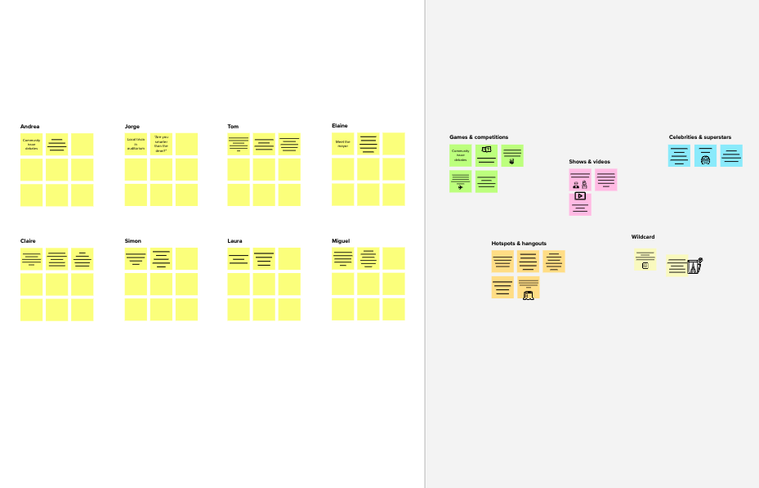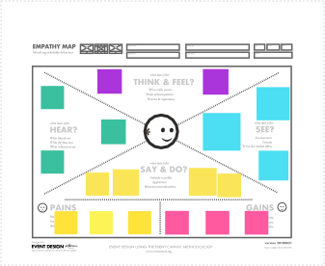

**Template**

**Need some inspiration?**

See a finished version of this template to kickstart your work.

[**Open example**](https://app.mural.co/template/e5a93b7b-49f2-48c9-afd7-a635d860eba6/93f1b98d-b2d2-4695-8e85-7e9c0d2fd9b9)